**Summary of The Articles**

**Title:** Comparative abilities of Microsoft Kinect and Vicon 3D motion capture for gait analysis

**Kinect type:** V1

**Year:** 2014

**Keywords:** Biomechanics, gait, Kinect, vicon

**Abstract:**

* Validity of Kinect v1 with Brekel Kinect Software:
  + for sagittal plane gait kinematics in clinical usage.
  + in comparsion to Vicon Nexus.
* 20 Healthy adults (11 male, 9 female) were tracked on a treadmill while jogging and running at three different speeeds.
* Measured:
  + concurrent hip and knee flexion
  + extension,
  + stride timing.
* Statistical Analysis:
  + Pearson Product Moment Correlation Coefficient
  + Bland Altman Mean

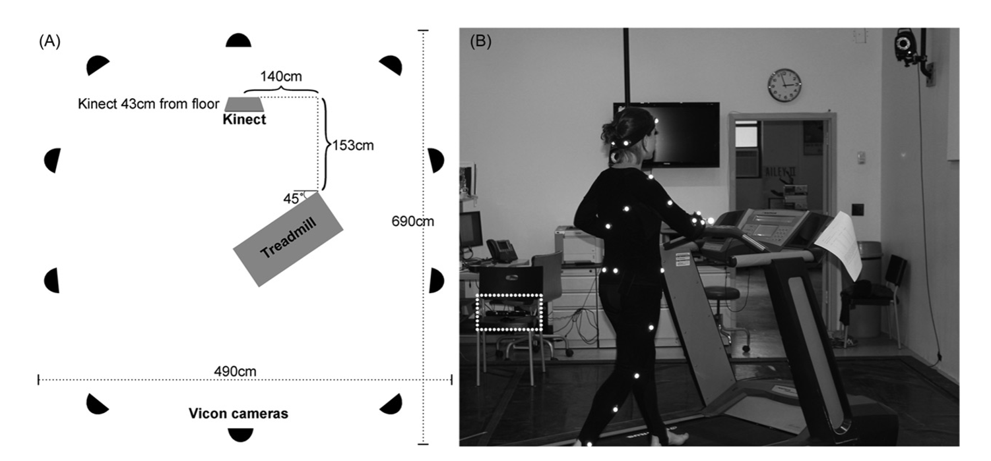

**Discussion:**

* Not acceptable for clinical measurements.
* Although some values correlate well, inconsistency carries on.
* Stride timing is well correlated.
* Can be clinically acceptable with development for temporal gait measurements.

**Final thoughts:**

* The results would be more accurate if the Kinect was placed perpendicular to the subject (e.g. frontal plane).
* Due to crossing, 8 – 18% of steps were missed. Multiple Kinects would solve the issue better.
* Slower Kinect sampling frequency of 30–37 Hz and insufficient smoothing algorithms may have contributed to Kinect’s inability to properly capture the flexion and extension peak amplitudes.

**Title:** Automated Evaluation of Upper-limb Motor Function Impairment using Fugl-Meyer Assessment

**Kinect type:** v2

**Year:** 2017

**Keywords:** Stroke, Fugl-Meyer assessment, automated upper-limb assessment, rule-based binary logic classification

**Abstract:**

* Upper extremity motor function analysis in stroke patients
* Automation of 79% of Fugl-Meyer Assessment using Kinect v2 and FSR
* 9 stroke patients
* Accuracy of 92%
* Statistical Analysis:
  + Kohen’s Kappa Coefficient

**Discussion:**

* The average accuracy of the automated FMA is very high.
* Few tests exhibited disagreement due to:
  + The low thumb tracking accuracy of Kinect v2 (forearm pronation and spunation)
  + Binary logic algorithm’s inbalanced threshold and inconsistent evaluation of clinicians tug tests
* Wearing tight clothes can reduce error in shoulder rotation evaluations
* A promising future clinical method